* Write a program to check if the element in the first half of a tuple are sorted in ascending order or not.

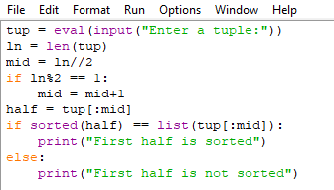

* Result





* Write a program to check if all the element of a tuple are in descending order or not.

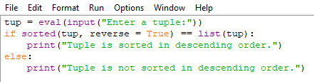

* Result



* 
* Write a program to check if a tuple contains any duplicate element.

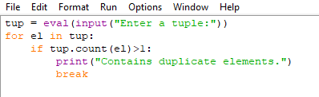

* Result

